**# 7 (OPTIONAL): Additional assessment that addresses NCTE standards**

**EED 400/380: Teaching Writing Rubric**

**Affiliated NCTE Content Standards:**

**II.1**: Candidates can compose a range of formal and informal texts taking into consideration the interrelationships among form, audience, context, and purpose; candidates understand that writing is a recursive process; candidates can use contemporary technologies and/or digital media to compose multimodal discourse.

**II.3**: Candidates are knowledgeable about how adolescents compose texts and make meaning through interaction with media environments.

**IV.1**: Candidates use their knowledge of theory, research, and practice in English Language Arts to plan standards-based, coherent and relevant composing experiences that utilize individual and collaborative approaches and contemporary technologies and reflect an understanding of writing processes and strategies in different genres for a variety of purposes and audiences.

**IV.2:** Candidates design a range of assessments for students that promote their development as writers, are appropriate to the writing task, and are consistent with current research and theory. Candidates are able to respond to student writing in process and to finished texts in ways that engage students’ ideas and encourage their growth as writers over time.

**IV.3:** Candidates design instruction related to the strategic use of language conventions (grammar, usage, and mechanics) in the context of students’ writing for different audiences, purposes, and modalities.

**IV.4:** Candidates design instruction that incorporates students’ home and community languages to enable skillful control over their rhetorical choices and language practices for a variety of audiences and purposes.

**Assessment Narrative**

1. Assessment #7 is a rubric that evaluates two major assignments in secondary English

education candidates’ required writing methods course (EED 400, renumbered EED 380 in the Fall 2018 semester). The two assignments evaluated include a 2-3 week genre-based writing unit and a personal writing portfolio.

1. All secondary English education students at The College of New Jersey are required

to take two secondary ELA methods courses. The first of these, EED 380: Teaching Writing, provides a grammar refresher, an introduction to unit and lesson planning, and an introduction to a variety of composing processes and methods for teaching writing. The second, EED 390: Methods of Teaching Secondary English, a course emphasizing reading methods, instructional planning, and a variety of socio-cultural approaches to the teaching of English is described in section 4-3 (Unit and Lessons Planning Rubric).

EED 380 is described on the syllabus as follows: “This course is intended to better prepare you to engage your future students in successful and purposeful writing experiences as you enter secondary classrooms as English teachers.  As we examine a variety of student-centered methods for teaching writing, you will be required to keep a writer’s notebook, familiarize yourself with and compose in a variety of genres, develop genre-based writing lessons and a writing unit overview, assemble a portfolio in which you showcase and reflect upon your written work, articulate your own instructional vision, and develop corresponding (i.e. pedagogically and politically consistent) practices. Additionally, and in order to “imagine the possible” for your students, you will be asked to revisit your own history as a writer and explore how your unique experiences continue to inform and shape your developing practice.”

Throughout EED 380, all English education candidates are required to

* demonstrate their proficiency and range as writers by crafting writing samples which reflect their mastery of an assortment of textual genres and digital platforms **(II.1)**
* examine their histories as writers
* collect and design instructional materials and assessments **(IV.1, IV.2, IV.3, IV.4)**
* articulate their philosophy of Teaching Writing based on the best practices they have encountered in course texts as well as in their experience as students and student teachers
* give and receive writing feedback from their instructor as well as their peers

All candidates required a rating of “Proficient” on the Teaching Writing Rubric to achieve established target levels of performance.

1. In the past two years, EED 380 has transitioned from a secondary ELA methods course candidates took after enrolling in their Clinical 1 semester to a course recommended prior to Clinical 1 (the primary reason for the course renumbering), or (in some cases) taken concurrent with Clinical 1. As a result, in the past two years, the curriculum of the course has been redesigned to provide greater emphasis on lesson planning and unit design in addition to the course’s focus on candidate writing development, writing methods, and writing assessment.

Our candidates’ cumulative ratings on all of the items on the rubric have been strong. At least 90% of our candidates received ratings of either proficient or exceptional in each assessment category, demonstrating their familiarity with digital writing and publishing platforms (98%) and composing processes (97%) as well as their ability to integrate in-context grammar instruction (97%) and explorations of language use in their unit and lesson planning (98%). In all four semesters, candidates demonstrated their ability to write in a variety of genres for different audiences and purposes. Over half of the candidates enrolled in the course in the Spring 2018 and Spring 2019 were rated as “Exceptional” in this category. Similarly, in all four semesters, a significant number of candidates demonstrated exceptional facility with digital media as writers and as teachers: Fall 2017 (45%), Spring 2018 (47%), Fall 2018 (33%), and Spring 2019 (69%). In other categories, the number of exception ratings varied by semester, but overall proficiency was achieved.

Specifically in the Fall 2017 semester, a greater number of students were identified as needing development as writers(Item 1: Composing, 5 candidates 13.5%), in their understanding of writing methods (Item 4: Composition Methods, 5 candidates 13.5%), and in their ability to create assessments and provide feedback (Item 5: Composition Assessment, 4 candidates, 11%). These numbers may have been anomalous to this particular cohort of candidates or possibly a result of the new placement of the course in the program sequence and a revised curriculum with greater emphasis on lesson and unit design. The majority of candidates enrolled in Teaching Writing this semester would have enrolled in EED 390: Methods in the spring (2018) where they would have received additional support developing units, lessons, and assessments (as well as in their student teaching and capstone courses the following year).

Also of note in the fall 2017 semester: There is no data reported for Item 7, Content Pedagogy: Composition Language. This was the result of confusion on the part of the instructor about how to evaluate this standard in candidates’ units and portfolios. Expectations were immediately clarified and all faculty who teach the course are now able to evaluate candidate work and provide data for this item and standard.

(d)

|  |  |  |
| --- | --- | --- |
| **NCTE Standards** | **Assessment Categories** | **Cumulative Performance Ratings**  **(Candidates Rated Proficient or Exceptional)** |
| II.1 | Content Knowledge: Candidate Writing; Technology Use | 90% Candidates are able to compose in a variety of genres for varied purposes and audiences;  98% Candidates able to use a variety of digital platforms to produce and publish writing. |
| II.3 | Composing Processes | 97% Candidates demonstrate understanding of student writing and meaning-making processes using print and digital texts. |
| IV.1 | Writing Methods | 93% Candidates plan writing lessons and units that model writing processes and draw on ELA theory and research on writing best practices. |
| IV.2 | Writing Assessment | 94% Candidates are able to develop writing assessments and provide both formative and summative feedback to encourage student writing growth. |
| IV.3 | Grammar | 97% Candidates familiar with grammatical terms and concepts and use in-context grammar instruction to develop student writing. |
| IV.4 | Language | 98% Students draw on community language practices to inform writing instruction. (*no data from the Fall 2017 semester). |

**Assessment Documentation**

(e) Assignment Description

**Genre-Specific Unit Calendar, Criteria Sheet, Mentor Text and Mini-Lesson:** For this assignment you will be responsible for envisioning a 2-3 week (10-15 day) instructional unit on a specific writing genre.  You will NOT be creating a full unit (as per EED 390). Instead, you will be expected to 

* develop a 2-3 week calendar overview of the unit
* identify three mentor texts that will be central to your instruction
* compose two craft-based (approx. 15 minute) mini-lessons, one of which you will teach in class
* create two 5-minute mini-lessons which you will create digitally using Screencastify (or another approved screencasting platform). One of these mini-lessons will focus on grammar/mechanics. The other will focus on revision.
* compose your own mentor text that reflects your unit’s genre (may also be used as one of your portfolio pieces)
* create a genre criteria guide that you could use for assessment purposes

**Teaching Writing Portfolio:** Although this project will be turned in during the week of final exams, you will be working on it all semester.  To create your electronic portfolio, you may choose from a variety of platforms: Google, Wix, Weebly, Tumblr or another platform approved by me. Drafts of most of the pieces included in the portfolio will be handed in, commented on, and returned *before* the final version is due. *I will award point for drafts submitted on time.  Late drafts will still receive feedback, but they will not earn submission credit.* The portfolio will include the following components:

1. *Writers Notebook Snapshot:* At the end of the semester you will choose 1-3 pages of your WNB to showcase.  In the portfolio, you will explain how these pages demonstrate your use of the WNB and your evolution as a writer and teacher of writing.
2. *“This I Believe…About Writing”*: An often-taught secondary genre is the “This I Believe Essay.”  You will be writing your own version as a way of stating your philosophy of teaching writing.
3. *5 personal choice pieces:* As a future teacher of writing, you will be expected to write both with and for your students.  These writing “samples” should demonstrate your writing proficiency as well as your familiarity with a variety of textual genres (including: poetry, literary letters, personal narratives, fiction, non-fiction, academic essays, digital writing, etc.).  We will begin, draft, and discuss many of these pieces in class; however, you are responsible for putting on the finishing touches. **\*Note:** One of these pieces must be your genre example from your unit, another may come from a class other than EED 380.
4. *2 choice piece “explications”*: For each of your included choice pieces, you will additionally include an explanation of (1) why you’ve decided to include this piece in the portfolio, (2) what writing skills/strategies/techniques are demonstrated in the piece (3) whether or not/how you might use this piece in your future classrooms.

(f) Teaching Writing Rubric

**EED 400/380: Teaching Writing (Rev. 2017)**

| **NCTE Standards** | **Exceptional (3 pts)** | **Proficient (2 pts)** | **Developing (1 pt)** | **Needs Improvement (0 pt)** |
| --- | --- | --- | --- | --- |
| **Content Knowledge: Composing (Self)  NCTE-2012.2.1** | TC can compose a range for formal and informal texts, taking into consideration the interrelationships among form, audience, context, and purpose; TC understands that writing is a recursive process. Meets expectations at least 90% of the time. | Meets expectations at least 80% of the time. | Meets expectations at least 70% of the time. | Meets expectations less than 70% of the time. |
| **Content Knowledge: Technology NCTE-2012.2.1** | TC can use contemporary technologies and/or digital media to compose multimodal discourse. Meets expectations at least 90% of the time. | Meets expectations at least 80% of the time. | Meets expectations at least 70% of the time. | Meets expectations less than 70% of the time. |
| **Content Knowledge: Composing (Student Process)  NCTE-2012.2.3** | TC is knowledgeable about how adolescents compose texts and make meaning through interactions with media environments. Meets expectations at least 90% of the time. | Meets expectations at least 80% of the time. | Meets expectations at least 70% of the time. | Meets expectations less than 70% of the time. |
| **Content Pedagogy: Composition Methods  NCTE-2012.4.1** | TC uses knowledge of theory, research, and practice in ELA to plan standards-based, coherent and relevant composing experiences that utilize individual and collaborative approaches and contemporary technologies and reflect and understand of writing processes and strategies in different genres for a variety of purposes and audiences. Meets expectations at least 90% of the time. | Meets expectations at least 80% of the time. | Meets expectations at least 70% of the time. | Meets expectations less than 70% of the time. |
| **Content Pedagogy: Composition Assessment NCTE-2012.4.2** | TC designs a range of assessments for students that promote their development as writers, are appropriate to the writing task, and are consistent with current research and theory. TCs are able to respond to student writing in process and to finished texts in ways that engage students’ ideas and encourage their growth as writers over time. Meets expectations at least 90% of the time. | Meets expectations at least 80% of the time. | Meets expectations at least 70% of the time. | Meets expectations less than 70% of the time. |
| **Content Pedagogy: Composition Grammar NCTE-2012.4.3** | TC designs instruction related to the strategic use of language conventions in the context of students’ writing for different audiences, purposes, and modalities. | Meets expectations at least 80% of the time. | Meets expectations at least 70% of the time. | Meets expectations less than 70% of the time. |
| **Content Pedagogy: Composition Language NCTE-2012.4.4** | TC designs instruction that incorporates students’ home and community languages to enable skillful choice over their rhetorical choices. | Meets expectations at least 80% of the time. | Meets expectations at least 70% of the time. | Meets expectations less than 70% of the time. |

(g) Data Charts

**Fall 2017**

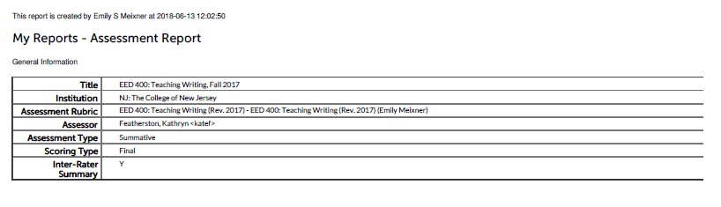

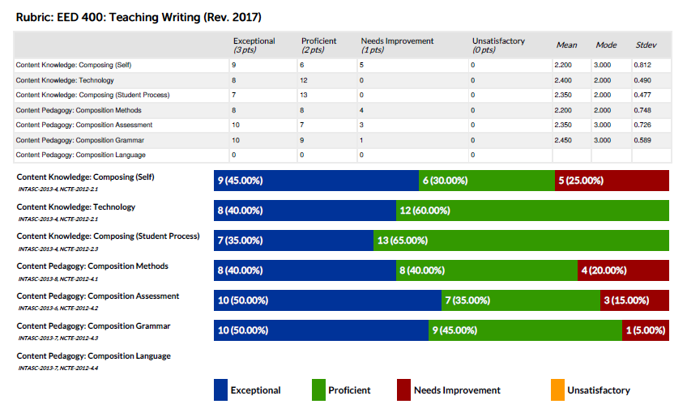

**Spring 2018**

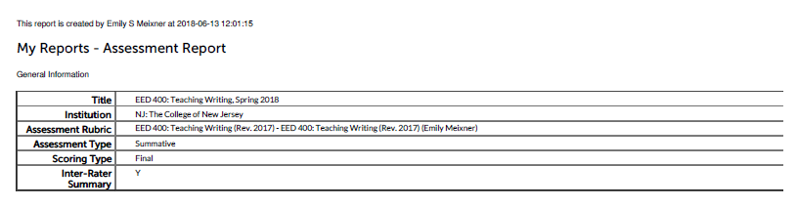

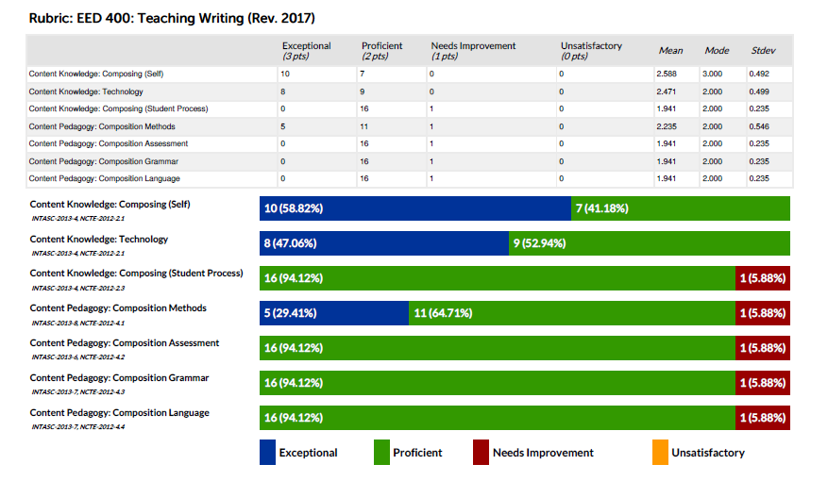

**Fall 2018 (Course Renumbered, EED 380)**

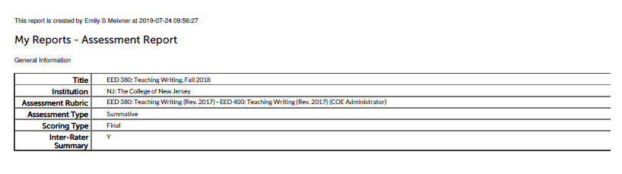

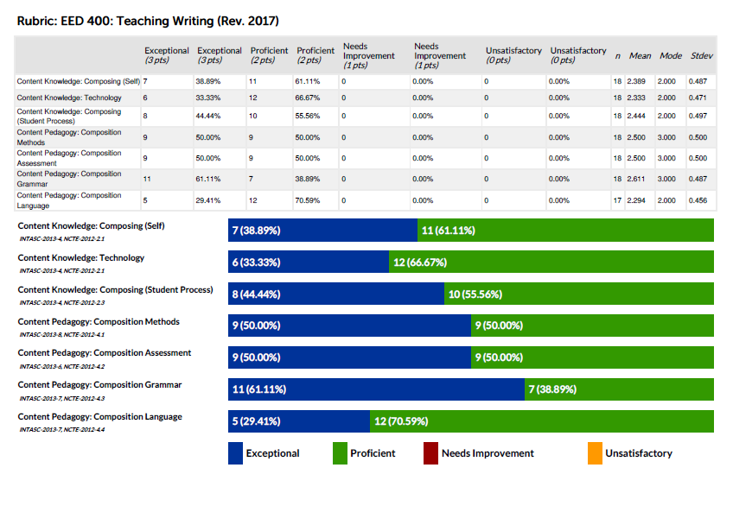

**Spring 2019**

