# 4 (REQUIRED): Assessment of student teaching

EED 490: Student Teaching, English Teaching Performance Assessment

Affiliated NCTE Content Standards:
I.1: Candidates are knowledgeable about texts—print and non-print texts, media texts, classic texts and contemporary texts, including young adult—that represent a range of world literatures, historical traditions, genres, and the experiences of different genders, ethnicities, and social classes; they are able to use literary theories to interpret and critique a range of texts.
II.2: Candidates know the conventions of English language as they relate to various rhetorical situations (grammar, usage, and mechanics); they understand the concept of dialect and are familiar with relevant grammar systems (e.g., descriptive and prescriptive); they understand principles of language acquisition; they recognize the influence of English language history on ELA content; and they understand the impact of language on society.
III.1: Candidates use their knowledge of theory, research, and practice in English Language Arts to plan standards-based, coherent and relevant learning experiences utilizing a range of different texts—across genres, periods, forms, authors, cultures, and various forms of media—and instructional strategies that are motivating and accessible to all students, including English language learners, students with special needs, students from diverse language and learning backgrounds, those designated as high achieving, and those at risk of failure.
III.2: Candidates design a range of authentic assessments (e.g., formal and informal, formative and summative) of reading and literature that demonstrate an understanding of how learners develop and that address interpretive, critical, and evaluative abilities in reading, writing, speaking, listening, viewing, and presenting.
IV.1: Candidates use their knowledge of theory, research, and practice in English Language Arts to plan standards-based, coherent and relevant composing experiences that utilize individual and collaborative approaches and contemporary technologies and reflect an understanding of writing processes and strategies in different genres for a variety of purposes and audiences.
IV.2: Candidates design a range of assessments for students that promote their development as writers, are appropriate to the writing task, and are consistent with current research and theory. Candidates are able to respond to student writing in process and to finished texts in ways that engage students’ ideas and encourage their growth as writers over time.
V.1: Candidates plan and implement instruction based on ELA curricular requirements and standards, school and community contexts, and knowledge about students’ linguistic and cultural backgrounds.
V.2: Candidates use data about their students’ individual differences, identities, and funds of knowledge for literacy learning to create inclusive learning environments that contextualize curriculum and instruction and help students participate actively in their own learning in ELA.
V.3: Candidates differentiate instruction based on students’ self-assessments and formal and informal assessments of learning in English language arts; candidates communicate with students about their performance in ways that actively involve them in their own learning.
V.4: Candidates select, create, and use a variety of instructional strategies and teaching resources, including contemporary technologies and digital media, consistent with what is currently known about student learning in English Language Arts.
VI.1: Candidates plan and implement English language arts and literacy instruction that promotes social justice and critical engagement with complex issues related to maintaining a diverse, inclusive, equitable society.
VI.2: Candidates use knowledge of theories and research to plan instruction responsive to students’ local, national and international histories, individual identities (e.g., race, ethnicity, gender expression, age, appearance, ability, spiritual belief, sexual orientation, socioeconomic status, and community environment), and languages/dialects as they affect students’ opportunities to learn in ELA.
VII.2: Candidates engage in and reflect on a variety of experiences related to ELA that demonstrate understanding of and readiness for leadership, collaboration, ongoing professional development, and community engagement.

Assessment Narrative:

- Assessment #4 is used to evaluate English education teacher candidates’ knowledge, skills, and abilities as the complete their student teaching/Clinical 2 field placement.

- As they assume instructional responsibility in middle and high school classrooms, English education candidates are expected to build on the planning and implementation skills they began developing in EED 380 (Teaching Writing), EED 390 (Methods of Teaching Secondary English), and their Clinical 1 field placement. Throughout their semester-long full-time placement at a local middle or high school (450 hours), candidates transition from co-teaching to independent instruction. By the end of the semester, they are expected to be able to create an inclusive and supportive learning environment for all students (V.2) that draws on their awareness of the school community and students’ cultural backgrounds (V.1, VI.2); select and design appropriate English Language Arts curricula that uses a range of print and digital texts to integrate instruction in reading, language, literature, and composition (I.1, II.2, III.1, V.4, IV.1); align their instruction with the New Jersey Language Arts Core Curriculum Content Standards (III.1); demonstrate a variety of collaborative and differentiated teaching strategies’ that
motivate and capture students’ interests (V.3) and require critical thinking (VI. 1); engage their students in interpreting, evaluating and producing oral, written, and visual texts (III.2, IV.2); integrate a variety of formal and informal assessment techniques (III.2, IV.2); form collegial relationships with peers, faculty, and school personnel; demonstrate ethical decision making; and provide evidence of reflective practice (VII.2).

All candidates need to receive a rating of “Proficient” to achieve established target levels of performance.

- Our data indicates that as our candidates matriculate through their clinical semesters, their planning and teaching steadily improve. They are consistently demonstrating their ability to model reading and analysis strategies, and they are teaching composition in both workshop and literature-driven contexts. While the majority of our candidates were achieving proficient ratings on their lesson plans at the end of Clinical 1 (*see assessment 4-3 Unit and Lessons planning rubric), upon completion of Clinical 2, 44 out of 53 candidates (83%) received “Exceptional” ratings in the Written Lesson Plan category on their final Clinical 2 assessments (Rubric Item 1). Additionally, all of our candidates were rated either “Exceptional” or Proficient” in both content knowledge categories (general and language/linguistics) as well as in critical thinking. Although we weren’t able to evaluate all of our candidates on their language instruction in Clinical 1 (*see assessment 4-3 Unit and Lessons planning rubric), we were able to obtain a more complete portrait of their content knowledge here (*see also 4-5edTPA). One final category in which more than 80% of our candidates received an “Exceptional” rating was Teacher Presence.

Our candidates are also demonstrating their ability to integrate a variety of instructional strategies, including instructional technologies and digital media when they are available at candidates’ school sites. 43 candidates (78%) received “Exceptional” ratings in the Instructional Strategies/Technology Category (Rubric Item 13). Finally, our candidates are working to ensure that their classrooms are inviting and accessible to all students. This is visible in their cultural awareness (Rubric Item 2, 96% of candidates rated “Exceptional” or “Proficient), in the classroom environments they are working to cultivate (Rubric Item 11, 94% “Exceptional” or “Proficient”), and in their efforts to connect the curriculum to their students’ lives (Rubric Item 9, 100% “Exceptional” or “Proficient”).

At the end of both academic years, we did identify candidates who had not achieved proficiency in several categories on the English Teaching Performance Rubric. These individuals did not receive grades sufficient for certification. They either chose to repeat their clinical 2 experience or to change their major to English Liberal Arts and graduate without certification.

- Articulation to Standards
NCTE Standards | Assessment Categories | Cumulative Performance Ratings  (Candidates rated Proficient or Exceptional)
I.1 | Content Knowledge, Lesson Planning | 100% Candidates demonstrate familiarity with a range of texts. literary traditions, and literary theory.
II.2 | Language/Grammar | 100% Candidates demonstrate knowledge of language history, grammatical terminology, dialectical differences.
III.1 | Reading/Literature Instruction | 96% Candidates are able to draw from a range of texts (print and digital) to plan motivational, engaging, accessible lesson plans that are content-rich, and standards-based.
III.2 | Reading Assessment | 98% Candidates are able to develop formative and summative assessments that evaluate students’ interpretive, critical, and evaluative abilities in reading, writing, speaking, listening, viewing, and presenting.
IV.1 | Composition | 98% Candidates are able to plan writing lessons that draw on current research on student writing processes, offer individual and collaborative writing opportunities, and require students to compose in different modes and for different purposes and audiences.
IV.2 | Writing Assessment | 96% Candidates create formative and summative writing assessments that encourage student writing growth.
V.1 | Written Lesson Plan | 96% Candidates are able to plan and implement ELA lessons that are context and community-based.
V.2 | Classroom Environment | 94% Candidates create inclusive learning, community-centered environments based on students’ unique needs, experiences, and cultures.
V.3 | Differentiated Instruction | 96% Candidates use assessments to provide individual and group feedback as well as differentiate instruction.
V.4 | Instructional Technology | 98% Candidates are familiar with a variety of instructional platforms and incorporate technology as well as digital texts into their instruction.
VI.1 | Critical Thinking | 100% Candidates plan lessons that explore questions of power, privilege, equity and require students to think critically about themselves, their communities, and the world.
VI.2 | Cultural Awareness | 96% Candidates plan instruction that is aware of students’ unique and collective identities (racial, religious, linguistic, geographical, gendered, etc.)
VII.2 | Professional Dispositions | 94% Candidate demonstrate initiative as they reflect on their personal and profession growth and their collaboration with school constituents (students, colleagues, families, community members)

Assessment Documentation

- Assignment

Course Description for EED 490: Teaching during the senior year with approved teachers in the public schools. Supervised and observed by college and public school teachers. Observation, participation, and responsible teaching. Required for English education students.

- English Teaching Performance Assessment Rubric

 | Exceptional: Meets expectations at least 90% of the time. (4 pts) | Proficient: (3 pts) | Developing: (2 pts) | Needs Improvement: (1 pt) | NA (0 pt)
Learners and Learning: Written Lesson Plan  NCTE-2012.5.1 | Lesson plans are detailed and clear; have assessable performance-based objectives, have a logical flow; are developmentally appropriate, build on student prior knowledge, and reflect reflect deep content knowledge, and demonstrate the role of arts and humanities in learning. Meets expectations at least 90% of the time. | Meets expectations at least 80% of the time. | Meets expectations at least 70% of the time. | Does not meet program expectations.
Professional Knowledge and Skills: Cultural Awareness  NCTE-2012.6.2 | TC uses knowledge of theories and research to plan instruction responsive to students’ location, national, and international histories, individual identities, and languages/dialects as they affect students’ opportunities to learn in ELA. Meets expectations at least 90% of the time. | Meets expectations at least 80% of the time. | Meets expectations at least 70% of the time. | Does not meet program expectations.
Content Knowledge NCTE-2012.1.1 | Plans reflect deep knowledge of texts – print and non-print, media, classic and contemporary, including YA – that represent a range of literatures. Meets expectations at least 90% of the time. | Meets expectations at least 80% of the time. | Meets expectations at least 70% of the time. | Does not meet program expectations.
Content Knowledge: Language/Grammar NCTE-2012.2.2 | TC knows the conventions of the English language as they relate to various rhetorical situations; they understand dialect and are familiar with relevant grammar systems; they understand principles of language acquisition; they recognize the influence of English language history on ELA content; and they understand the impact of language on society. Meets expectations at least 90% of the time. | Meets expectations at least 80% of the time. | Meets expectations at least 70% of the time. | Does not meet program expectations.
Content Pedagogy: Reading and Literature Instruction  NCTE-2012.3.1 | TC uses knowledge of theory, research, and practice in ELA to plan coherent and relevant learning experiences utilizing a range of different texts. Instructional strategies are motivating and accessible to all students. Meets expectations at least 90% of the time. | Meets expectations at least 80% of the time. | Meets expectations at least 70% of the time. | Does not meet program expectations.
Content Pedagogy: Reading Assessment NCTE-2012.3.2 | TC designs a range of authentic assessments of reading and literature that demonstrate an understanding of how learners develop and that address interpretive, critical and evaluative abilities in reading, writing, speaking, listening, viewing, and presenting. Meets expectations at least 90% of the time. | Meets expectations at least 80% of the time. | Meets expectations at least 70% of the time. | Does not meet program expectations.
Content Pedagogy: Composition  NCTE-2012.4.1 | TC uses knowledge of theory, research, and practice in ELA to plan coherent and relevant composing experiences that utilize individual and collaborative approaches and contemporary technologies and reflect and understand of writing processes and strategies in different genres for a variety of purposes and audiences. Meets expectations at least 90% of the time. | Meets expectations at least 80% of the time. | Meets expectations at least 70% of the time. | Does not meet program expectations.
Content Pedagogy: Writing Assessment  NCTE-2012.4.2 | TC designs a range of assessments for students that promote their development as writers, are appropriate to the writing task, and are consistent with current research and theory. TCs are able to respond to student writing in process and to finished texts in ways that engage students’ ideas and encourage their growth as writers over time. Meets expectations at least 90% of the time. | Meets expectations at least 80% of the time. | Meets expectations at least 70% of the time. | Does not meet program expectations.
Professional Knowledge and Skills: Critical Thinking  NCTE-2012.6.1 | TC plans and implements ELA and literacy instruction that promotes social justice and critical engagement with complex issues related to maintaining a diverse, inclusive, equitable society. | Meets expectations at least 80% of the time. | Meets expectations at least 70% of the time. | Does not meet program expectations.
Teacher Presence | TC has a confident teaching presence. Exhibits an appropriate demeanor through tone of voice, body language and communicates effectively in standard English. Responds to students in a positive manner. Meets expectations at least 90% of the time. | Meets expectations at least 80% of the time. | Meets expectations at least 70% of the time. | Does not meet program expectations.
Learners and Learning: Classroom Environment  NCTE-2012.5.2 | TC uses data about their students’ individual differences, identities, and fund of knowledge for literacy learning to create inclusive learning environments that contextualize curriculum and instruction and help students participate actively in their own ELA learning. Meets expectations at least 90% of the time. | Meets expectations at least 80% of the time. | Meets expectations at least 70% of the time. | Does not meet program expectations.
Classroom Management | TC understands relationship between curriculum, instruction, and management. Successfully uses a variety of structures for student interaction and provides opportunities for student feedback and reflection. Meets expectations at least 90% of the time. | Meets expectations at least 80% of the time. | Meets expectations at least 70% of the time. | Does not meet program expectations.
Learners and Learning: Instructional Strategies, Technology  NCTE-2012.5.4 | Candidates select, create, and use a variety of instructional strategies and teaching resources, including contemporary technologies and digital media. Meets expectations at least 90% of the time. | Meets expectations at least 80% of the time. | Meets expectations at least 70% of the time. | Does not meet program expectations.
Learners and Learning: Differentiated Instruction  NCTE-2012.5.3 | Candidates differentiate instruction based on students’ self-assessments and formal/informal assessments of ELA learning. Candidates communicate with students about their performance in ways that actively involve them in their own learning. Meets expectations at least 90% of the time. | Meets expectations at least 80% of the time. | Meets expectations at least 70% of the time. | Does not meet program expectations.
Professional Knowledge and Skills: Professional Dispositions  NCTE-2012.7.2 | TC engages in and reflects on a variety of experiences related to ELA that demonstrates an understanding of and readiness for leadership, collaboration, ongoing professional development, and community engagement. Meets expectations at least 90% of the time. | Meets expectations at least 80% of the time. | Meets expectations at least 70% of the time. | Does not meet program expectations.

- Data Charts

Fall 2017

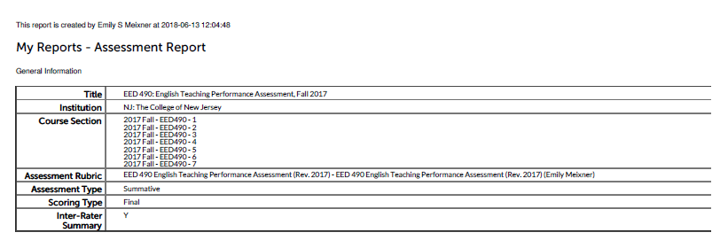
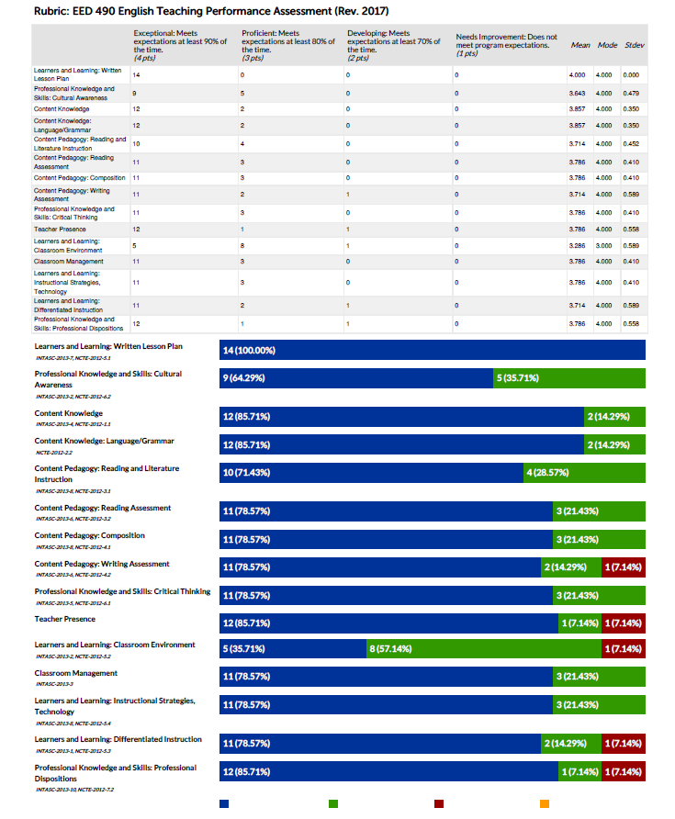

Spring 2018

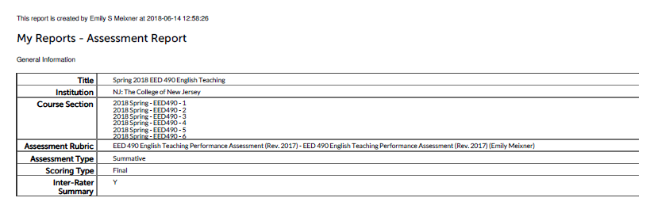
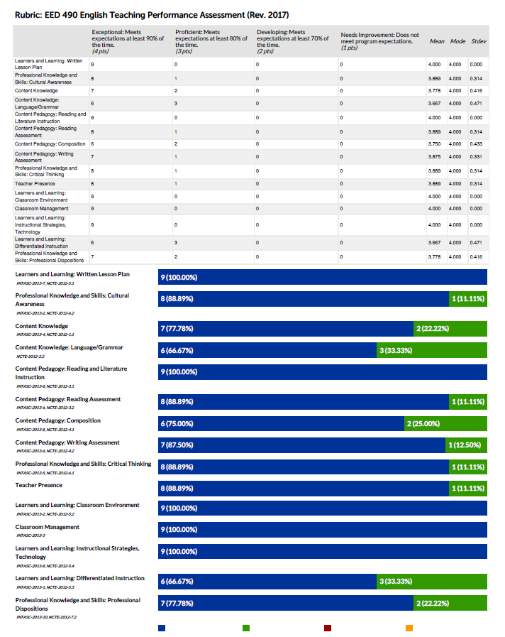

Fall 2018

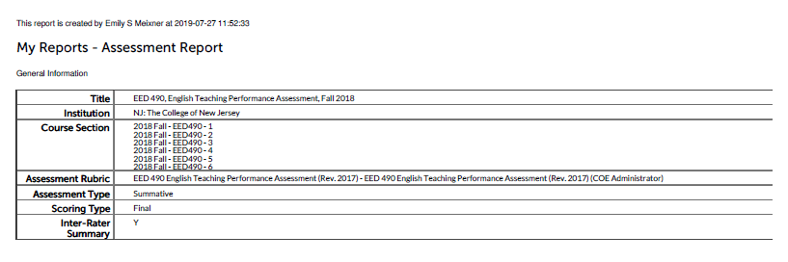
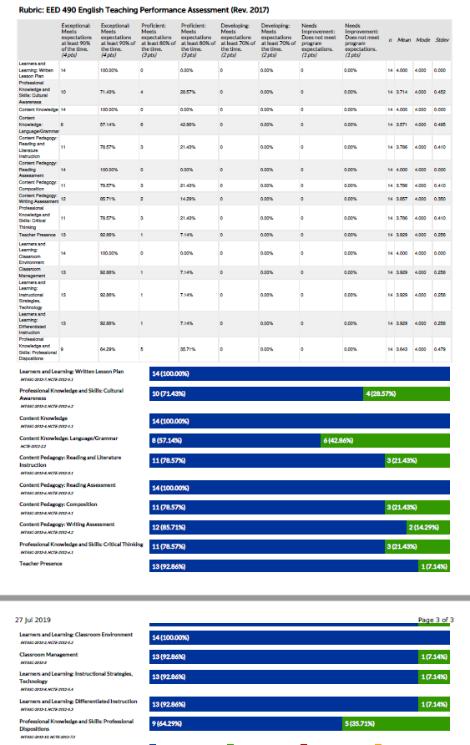

Spring 2019

