**# 3 (REQUIRED): Assessment of candidate ability to plan instruction**

**EED 390: Unit and Lessons Plans Rubric**

**Affiliated NCTE Content Standards:**

**I.2:** Candidates are knowledgeable about how adolescents read texts and make meaning through interaction with media environments.

**III.1:** Candidates use their knowledge of theory, research, and practice in English Language Arts to plan standards-based, coherent and relevant learning experiences utilizing a range of different texts—across genres, periods, forms, authors, cultures, and various forms of media—and instructional strategies that are motivating and accessible to all students, including English language learners, students with special needs, students from diverse language and learning backgrounds, those designated as high achieving, and those at risk of failure.

**III.2:** Candidates design a range of authentic assessments (e.g., formal and informal, formative and summative) of reading and literature that demonstrate an understanding of how learners develop and that address interpretive, critical, and evaluative abilities in reading, writing, speaking, listening, viewing, and presenting.

**III.3:** Candidates plan standards-based, coherent and relevant learning experiences in reading that reflect knowledge of current theory and research about the teaching and learning of reading and that utilize individual and collaborative approaches and a variety of reading strategies.

**III.4:** Candidates design or knowledgeably select appropriate reading assessments that inform instruction by providing data about student interests, reading proficiencies, and reading processes.

**III.5:** Candidates plan instruction that incorporates knowledge of language—structure, history, and conventions—to facilitate students’ comprehension and interpretation of print and non-print texts.

**III.6**: Candidates plan instruction which, when appropriate, reflects curriculum integration and incorporates interdisciplinary teaching methods and materials.

**V.1:** Candidates plan and implement instruction based on ELA curricular requirements and standards, school and community contexts, and knowledge about students’ linguistic and cultural backgrounds.

**V.3:** Candidates differentiate instruction based on students’ self-assessments and formal and informal assessments of learning in English language arts; candidates communicate with students about their performance in ways that actively involve them in their own learning.

**V.4:** Candidates select, create, and use a variety of instructional strategies and teaching resources, including contemporary technologies and digital media, consistent with what is currently known about student learning in English Language Arts.

**VI.1:** Candidates plan and implement English language arts and literacy instruction that promotes social justice and critical engagement with complex issues related to maintaining a diverse, inclusive, equitable society.

**VII.1:** Candidates model literate and ethical practices in ELA teaching, and engage in/reflect on a variety of experiences related to ELA.

**Assessment Narrative:**

1. Assessment #3 is the first of two assessments used to evaluate candidates’ ability to develop and implement original units of instruction. [*see also section 4-4 (English Teaching Performance Assessment)].
2. The primary focus of EED 390: Methods of Teaching Secondary English is ELA methods acquisition as well as lesson and unit design with an emphasis on reading strategy development and literature instruction. Candidates enroll in EED 390 as a part of their Clinical 1 experience, a block of three required courses (EED 390: Methods of Teaching Secondary English, SED 399: Pedagogy in Secondary Schools, and RAL 328: Reading in Secondary Education) that includes an extended field placement (189 hours). Candidates must successfully complete Clinical 1 in order to move into Clinical 2/Student Teaching.

One of the primary tasks of EED 390 is the construction of an original 8-10 day unit plan of sequenced lessons based on their school’s curriculum that candidates then teach in their clinical placement **(V.1)**. In the construction of their units, candidates demonstrate their developing understanding of adolescent reading as they design standards-based, content-rich instruction as well as develop formative and summative assessments to evaluate their students’ learning. Goals of the assignment include:

1. Using knowledge of learning and development to create an engaging, supportive, and challenging learning environment **(I.2, III.1., III.3, III.5)**
2. Designing instruction that draws connections across the curriculum, adapts to the diverse needs of learners and promotes critical thinking, problem solving and performance skills **(V.4, III.6, VI.1)**
3. Designing different kinds of assessments and using a variety of assessment strategiesto guide instruction **(III.2, III.4, V.3)**
4. Demonstrating understanding of professional guidelines, the capability of upholding ethical standards, and the advocacy of children **(VII.1)**
5. Engaging in reflection **(VII.1)**

Candidates receive feedback on their units from their cooperating teachers and faculty in both EED 390 and SED 399. The lesson plans and unit are then evaluated in EED 390: Methods of Teaching Secondary English using the Unit and Lesson Plans Rubric.

All candidates need to receive a rating of “Proficient” to achieve established target levels of performance.

1. As they complete EED 390 and their Clinical 1 semester, the majority of our secondary English education candidates are able to create substantive standards-based unit and lesson plans that are engaging and motivating. Candidates are also able to implement their lessons in their field placements. As they develop their units, our candidates are aware of, adapting to, and (sometimes) facilitating change in the school and classroom environments in which they are teaching. Our candidates are familiar with a variety of strategies for reading and literary analysis, and we are seeing evidence of both in their planning. The categories in which our candidates perform most strongly (with the most Exceptional ratings) are Item 4 on the rubric “Content Pedagogy: Literature and Reading Instruction, Lesson Planning” in which they integrate ELA theory, research, and practice while using a range of texts, and Item 13 “Professional Knowledge and Skills: Ethical Practice” in which they model literate and ethical practices as well as reflect on their experiences in ELA classrooms.

While many of our candidates are able to integrate language instruction into their units and lesson plans, because of the topics they are assigned by their cooperating teachers to teach, some are not (rubric item 7). As a result, while most candidates who are teaching lessons with language/linguistics content are proficient (40/42, 95%), we were not able to evaluate all 55 candidates using this category on the rubric. Similarly, because of the content and scope of our candidates’ units and lessons, it was difficult for many to integrate interdisciplinary teaching methods (rubric item 8). Of our 55 candidates, all 29 who were able to do so were rated either proficient or exceptional (100%). In order to get a more extensive and accurate portrait of candidates’ performance in these two categories they are also assessed in section 4-5 (edTPA).

For the candidates who were rated as developing (or, in one instance, needs improvement), in some cases, their grades did not meet the entrance requirements for Clinical 2 and were either counseled out of the secondary education program or required to retake EED 390/SED 399. In other instances, candidates met with their clinical faculty to create a set of expectation and put in place a remediation plan for Clinical 2.

|  |  |  |  |
| --- | --- | --- | --- |
| **NCTE Standards** | **Assessment Categories** | **Cumulative Performance Ratings**  **(Candidates rated Proficient or Exceptional)** | |
| I.2 | Reading Processes | 94.5% Candidates demonstrate familiarity with adolescent reading processes. | |
| III.1 | Literature and Reading Instruction | Rubric Item 3: 91%  Rubric Item 4: 94.5% | Candidates are able to draw from a range of texts (print and digital) to plan motivational, engaging, accessible lesson plans that are content-rich, and standards-based. |
| III.2 | Assessment | 92.7% Candidates are able to develop formative and summative assessments. | |
| III.3 | Reading Strategies | 91% Candidates are able to provide reading strategy instruction that is based in current research and theory. | |
| III.4 | Reading Assessment | 89% Candidates are able to craft assessments that evaluate student reading interests, proficiencies, and processes. | |
| III.5 | Language/Linguistics | 95% (42 candidates scored) Candidate are able to integrate the teaching of language in their lessons. | |
| III.6 | Lesson Planning | 100% (29 candidates scored) Candidates integrate content and methods from other disciplines. | |
| V.1 | Lesson Planning | 96% Candidates are able to plan and implement ELA lessons that are context and community-based. | |
| V.3 | Differentiated Instruction | 92.7% Candidates use assessments to provide individual and group feedback as well as differentiate instruction. | |
| V.4 | Lesson Planning | 94% Candidates are familiar with a variety of instructional platforms and incorporate technology as well as digital texts into their instruction. | |
| VI.1 | Critical Thinking | 96% Candidates plan lessons that explore questions of power, privilege, equity and require students to think critically about themselves, their communities, and the world. | |
| VII.1 | Ethical Practice | 98% Candidates demonstrate ethical behavior and model literacies foundational to ELA. | |

**Assessment Documentation**

1. Unit and Lesson Planning Assignment

**Overview:** As a program requirement, you are expected to design, teach and assess learning in an instructional unit. The unit is to be planned as a series of 8-10 connected lessons which you will teach during the course of your practicum at the school site where you are placed. You will plan the unit based on a theme or topic that is approved by the cooperating teacher, and which aligns with and lends to the (practicum) school’s curriculum. The lessons should be conceptually integrated. The unit will begin with a lesson that introduces the unit topic and end with a culminating activity. You will also reflect on your teaching and student learning as you teach your unit.

Required Format:

**I. Title**

**II. Table of Contents**

**III. Rationale-** compose a detailed statement that explains the enduring understandings the unit will develop.

**IV. Visual representation(s)/Overview —**designaconcept map(s), flow chart, calendar or other graphic organizers that visually represent the integration of the unit content.

**V. Preparing the learning environment**—describe how you set up the physical space and learning environment to support teaching your unit.

**VI. Unit Essential Questions**— identify the key questions that focus your unit.

**VII. Lesson Plans** — design lessons that include the following elements:

A.) Lesson rationale and/or essential questions

B.) Student learning goals

1.) specify objectives

2.) identify Common Core Standards for Mathematics

3 ) specify assessment strategy for each objective

C.) Procedure

1.) “the hook” (motivating strategy)

2.) lesson activities & experiences

3.) key questions, examples and modeling

4.) summary/ closure

D) Resources and supporting documents (include appropriate concrete materials, stimulating curricula, and technological tools that will be used to build students’ understanding of mathematical concepts.)

E) Reflection – should be grounded in evidence and consider implications for future student learning.

The lesson plans should

* Activate student interest and motivation
* Deliver content rich instruction
* Encourage problem solving, exploration, critical thinking skills, and active engagement *(by means of lesson activities, experiences and questions*)
* Utilize different instructional strategies including cooperative learning, collaboration, independent and small group tasks (*by means of pedagogical content specific strategies)*
* Apply assessment principles and use various tools and strategies both formal and informal e.g. observation, questioning, criterion and/or standardized tests, projects, peer assessment, portfolio of student work, etc., that assess student learning and progress.
* Adapt the lesson to meet the needs of diverse (abilities, learning styles, culture) learners in the classroom

**VIII Unit Culminating Assessment** —describe how unit closing experience connects back to unit goals.

**IX. Home/School/Community Connection (Except SEC-ED)** — e.g. compose a letter home; suggest a reading list for families; recommend parent/child enrichment activity suggestions.

**Secondary English UNIT PLAN TEMPLATE**

**Teacher Name:** **Subject:**  **Grade:**

**STAGE I**

|  |  |  |
| --- | --- | --- |
| **TITLE OF UNIT:** | | |
| **Enduring Understandings/Essential Questions**  *These are ideas, questions and goals (one or two) that frame learning throughout a unit of study.*  *Why are students learning the information/skills in this unit?* | | |
|  | | |
| **Learning Objectives – How will students *think* critically about content?**  *These should be listed in the order in which you plan to teach them. Each Learning Objective should correspond to the Aim/Focus Question for each lesson.*  *Ex. Students will be able to* ***analyze*** *how racism influences characters’ choices in chapter three.* | | |
|  | | |
| **Transferable Skills—What skills will students learn and use beyond this unit?**  *These may be repeated throughout several lessons.*  *Ex. Close reading, presentation skills, analytical essay writing, evaluating websites.* | | |
|  |  |  |
| **Dispositions – How will students develop personally?**  *These may be repeated throughout several lessons.*  *Ex. Collaboration, responsibility, organization, perseverance* | | |
|  |  |  |
| **Standards**  *Copy and paste your content-specific standards below that correspond with your unit objectives.* | | |
|  | | |

**STAGE II**

|  |  |  |  |  |  |
| --- | --- | --- | --- | --- | --- |
| **Assessments Highlights**  *Aligned to identified content and skills taught* | | | | | |
| **Type** | | **Assessment Title** | **Description of Assessment** | **Objectives Assessed**  **(Learning/Skills/Dispositions)** | **Type of *Feedback* to be given to the students** |
| *Pre-* | |  |  |  |  |
| *FORMATIVE ASSESSMENTS* | *Daily/Ongoing* |  |  |  |  |
| *Benchmark* |  |  |  |  |
| *Benchmark* |  |  |  |  |
| *Summative* | |  |  |  |  |

**STAGE III**

|  |  |  |  |  |  |
| --- | --- | --- | --- | --- | --- |
|  | **Day 1** | **Day 2** | **Day 3** | **Day 4** | **Day 5** |
| **Lesson Topic/Focus Question** |  |  |  |  |  |
| **List Instructional Activities/**  **Assessments**  **(Bullet Points)** |  |  |  |  |  |
| **HW** |  |  |  |  |  |

|  |  |  |  |  |  |  |
| --- | --- | --- | --- | --- | --- | --- |
|  | **Day 6** |  | **Day 7** | **Day 8** | **Day 9** | **Day 10** |
| **Lesson Topic/Focus Question** |  |  |  |  |  |  |
| **List Instructional Activities/**  **Assessments**  **(Bullet Points)** |  |  |  |  |  |  |
| **HW** |  |  |  |  |  |  |

**Secondary English Lesson Plan Template**

Title: _____________________________ Unit #____ Lesson #_____ Day # _____

|  |  |  |
| --- | --- | --- |
| **Aim/Focus Question**  *Write out the Content Objective from the Unit Plan* | | |
|  | | |
| **Learning Objectives (SWBAT) with Standards Codes**  *Include the content objectives specific to the lesson, skills from the Unit Plan, and standard codes for each objective.* | | **Corresponding Assessments**  *Include the formative assessment or summative assessment that correspond to each objective.* |
| ***Daily* Content Objectives:** | | **Corresponding Assessments:** |
| **Skills Objectives:** | | **Corresponding Assessments:** |
| **Standards –** *Cut and paste full standards here.* | | |
|  | | |
| **Student Understandings/Misunderstandings/Misconceptions**  *What do you anticipate your students already know going into this lesson, misunderstanding, and having misconceptions of? How does this lesson relate to students’ lives/society?* | | |
|  | | |
| **Beginning (Do Now/Opening/Hook)**  *Your beginning should engage students in the material for the day and be related to the objectives above. It is good to make your beginning relevant to the students’ lives and to make an overt connection between the beginning and the Aim/objectives for the day.* | | |
|  | | |
| **Transition**– *Explicitly connect the discussion of the “Opening” to the day’s “Aim” and then to the first “Activity.”* | | |
|  | | |
| **Middle – Context/Application (Mini Lesson, Activity, Guided Practice)**  ***1)*** *Balance of* ***instructional time*** *and* ***time for application****;* ***2)******Transitions (in italics)*** *when moving to another topic/activity;* ***3)******Clear instructions*** *for the students (often in a* ***list/outline****) that you* ***model*** *activities for the students, when needed; and* ***4)******Questions*** *w/ anticipated answers.* | | |
|  | | |
| **Transition**– *Explicitly connect the discussion of the last activity in the “Middle” to the “Conclusion.”* | | |
|  | | |
| **End/Conclusion of the Lesson**  *End each lesson together as a class to sum up the material for the day and bring the class back to the “Learning Objectives” and “Aim” for the day.* *(For example, an “exit slip” or another short activity that brings the lesson full circle.)* | | |
|  | | |
| **Homework**  *What is the students’ homework to help them apply the knowledge they have learned from the day’s lesson?* | | |
|  | | |
| **Question Reflection**  *Copy and paste the key questions written out above in the categories listed below.*  (Remember, you may not have questions in all categories in every lesson.) | | |
| **Knowledge Questions:** | | |
| **Application Questions:** | | |
| **Critical Thinking Questions:** | | |
| **Differentiation**  *For each activity requiring differentiation, outline how specific you will adapt the activity to meet the needs of each type of learner.* | | |
| **Struggling** | **Accelerated** | |
| **Materials**  *List any materials you need for the lesson.* | | |
|  | | |

1. Unit and Lessons Planning Rubric

|  |  |  |  |  |
| --- | --- | --- | --- | --- |
|  | | | |  |
| NCTE Standards | **Exceptional**  **(3 pts)** | **Proficient**  **(2 pts)** | **Developing**  **(1 pt)** | **Needs Improvement**  **(0 pts)** |
| **Learners and Learning: Lesson Planning**  **NCTE-2012.5.1** | TC plans and implements instruction based on ELA curricular requirements and standards, school and community contexts, and knowledge about students’ linguistic and cultural backgrounds. Meets expectations at least 90% of the time. | Meets expectations at least 80% of the time. | Meets expectations at least 70% of the time. | Meets expectations less than 70% of the time. |
| **Learners and Learning: Lesson Planning**  **NCTE-2012.5.4** | TC selects, creates, and uses a variety of instructional strategies and teaching resources, including contemporary technologies and digital media. Meets expectations at least 90% of the time. | Meets expectations at least 80% of the time. | Meets expectations at least 70% of the time. | Meets expectations less than 70% of the time. |
| **Content Pedagogy: Literature and Reading Instruction (Lesson Planning)  NCTE-2012.3.1** | TC selects instructional strategies that are motivating and accessible to all students. Meets expectations at least 90% of the time. | Meets expectations at least 80% of the time. | Meets expectations at least 70% of the time. | Meets expectations less than 70% of the time. |
| **Content Pedagogy: Literature and Reading Instruction, Lesson Planning  NCTE-2012.3.1** | TC uses their knowledge of theory, research, and practice in ELA to plan standards-based, coherent and relevant learning experiences utilizing a range of different texts. Meets expectations at least 90% of the time. | Meets expectations at least 80% of the time. | Meets expectations at least 70% of the time. | Meets expectations less than 70% of the time. |
| **Content Knowledge: Reading Processes NCTE-2012.1.2** | TC is knowledgeable about how adolescents read texts and make meaning through interaction with media environments. Meets expectations at least 90% of the time. | Meets expectations at least 80% of the time. | Meets expectations at least 70% of the time. | Meets expectations less than 70% of the time. |
| **Content Pedagogy: Literature and Reading Instruction (Reading Strategies)  NCTE-2012.3.3** | TC plans (Standards-Based, Coherent, Relevant) learning experiences in reading that reflect knowledge of current theory and research about the teaching and learning of reading and that utilize individual and collaborative approaches and a variety of reading strategies. Meets expectations at least 90% of the time. | Meets expectations at least 80% of the time. | Meets expectations at least 70% of the time. | Meets expectations less than 70% of the time. |
| **Content Pedagogy: Literature and Reading Instruction (Language)**  **NCTE-2012.3.5** | TC plans instruction that incorporates knowledge of language -- structure, history, and conventions -- to facilitate students' comprehension and interpretation of print and non-print texts. Meets expectations at least 90% of the time. | Meets expectations at least 80% of the time. | Meets expectations at least 70% of the time. | Meets expectations less than 70% of the time. |
| **Content Pedagogy: Literature and Reading Instruction (Lesson Planning) NCTE-2012.3.6** | TC plans instruction which, when appropriate, reflects curriculum integration and incorporates interdisciplinary teaching methods and materials. Meets expectations at least 90% of the time. | Meets expectations at least 80% of the time. | Meets expectations at least 70% of the time. | Meets expectations less than 70% of the time. |
| **Content Pedagogy: Literature and Reading Instruction (Assessment) NCTE-2012.3.2** | TC designs a range of assessments of reading and literature that demonstrate and understanding of how learners develop and that address interpretive, critical, and evaluative abilities (reading, writing, speaking, listening, viewing, presenting). Meets expectations at least 90% of the time. | Meets expectations at least 80% of the time. | Meets expectations at least 70% of the time. | Meets expectations less than 70% of the time. |
| **Content Pedagogy: Literature and Reading Instruction (Reading Assessment)  NCTE-2012.3.4** | TC designs or knowledgeably selects appropriate reading assessments that inform instruction by providing data about students’ interests, reading proficiencies, and reading processes. Meets expectations at least 90% of the time. | Meets expectations at least 80% of the time. | Meets expectations at least 70% of the time. | Meets expectations less than 70% of the time. |
| **Learners and learning: Differentiated Instruction NCTE-2012.5.3** | TC differentiate instruction based on students’ self-assessments and formal/informal assessments of ELA learning. TC communicates with students about their performance in ways that actively involve them in their own learning. Meets expectations at least 90% of the time. | Meets expectations at least 80% of the time. | Meets expectations at least 70% of the time. | Meets expectations less than 70% of the time. |
| **Professional Knowledge and Skills: Critical Thinking  NCTE-2012.6.1** | TC plans and implements ELA and literacy instruction that promotes social justice and critical engagement with complex issues related to maintaining a diverse, inclusive, equitable society. Meets expectations at least 90% of the time. | Meets expectations at least 80% of the time. | Meets expectations at least 70% of the time. | Meets expectations less than 70% of the time. |
| **Professional Knowledge and Skills: Ethical Practice  NCTE-2012.7.1** | TC models literate and ethical practices in ELA teaching and engage in/reflect on a variety of experiences related to ELA. Meets expectations at least 90% of the time. | Meets expectations at least 80% of the time. | Meets expectations at least 70% of the time. | Meets expectations less than 70% of the time. |

1. Data Charts

**Fall 2017: The course was not offered this semester as the college was transitioning students into the new sequence of clinical experiences. Data is therefore provided for Spring 2018, Fall 2018, and Spring 2019.**

**Spring 2018**

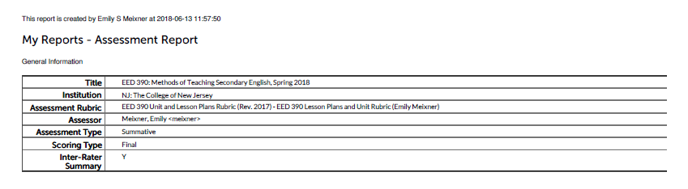

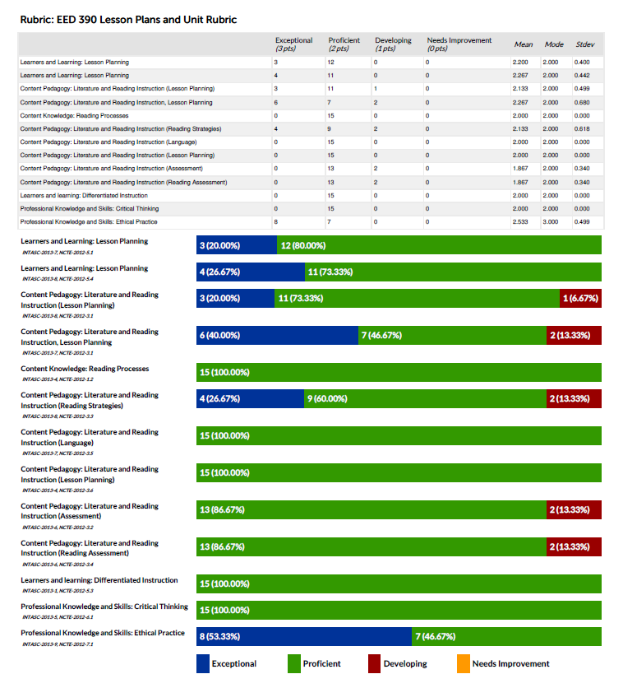

**Fall 2018**

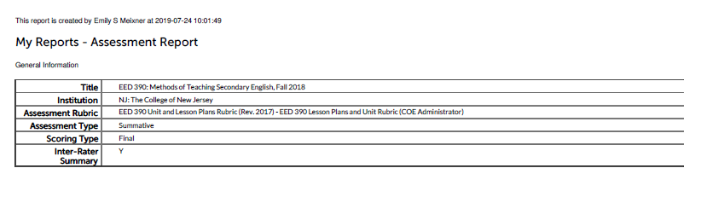

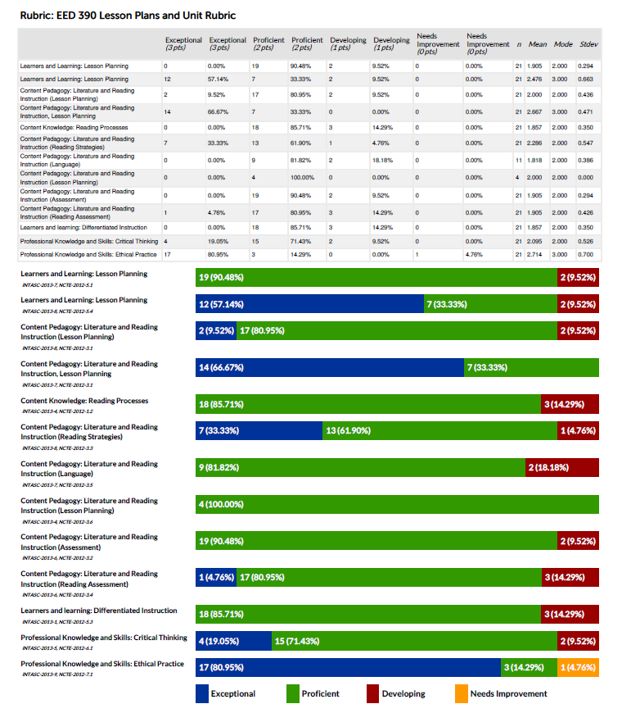

**Spring 2019**



