**#2 (Required)-CONTENT KNOWLEDGE: Assessment of content knowledge in the English language arts.**

**LIT 200: Poetry Analysis Question**

**LIT 201: Critical Approaches Question**

**LIT 499: Research Paper**

**Affiliated NCTE Content Standards:**

I. 1: Candidates are knowledgeable about texts—print and non-print texts, media texts, classic texts and contemporary texts, including young adult—that represent a range of world literatures, historical traditions, genres, and the experiences of different genders, ethnicities, and social classes; they are able to use literary theories to interpret and critique a range of texts.

II. 1: Candidates can compose a range of formal and informal texts taking into consideration the interrelationships among form, audience, context, and purpose; candidates understand that writing is a recursive process; candidates can use contemporary technologies and/or digital media to compose multimodal discourse.

**Assessment Narrative:**

1. Assessment #2 is one of two English department-specific assessments being used to measure secondary English education candidates’ content knowledge (*see also section 4-6 Content Exam for Secondary English Educators). In this bundled assessment, data is being collected on our teacher candidates’ ability to read, analyze, and write about literature (**I.1, II. 2**). Specifically, we are evaluating our candidates’ ability to understand and apply literary theory and criticism (**I.1**), synthesize secondary sources, and draft and compose both short and extended literary analyses across genres and periods (**II. 1**).
2. As the candidates matriculate through the English program, they are expected to meet a series of departmental learning outcomes that align with the content standards articulated by NCTE. Specifically, candidates are expected to

* demonstrate familiarity with a range of critical, generic, and literary traditions (including recent theoretical approaches) that shape – and are shaped by – literary discourses and texts of particular periods or movements **(I.1)**
* describe the effects of social constructions of identity on a particular literary text and on current debates over aesthetic value, universality, and canonicity (**I.1)**;
* identify historically specific elements relevant to a particular text **(II.1);**
* read a literary work and characterize its main aesthetic, structural, and rhetorical strategies in an argumentative, thesis-driven essay or in a writing workshop (**II.1)**;
* write a substantial essay of literary scholarship that is theoretically informed and engages with current research and criticism in relevant fields of study, asserting their own critical voice in ongoing dialogues and debates (**II.1)**;
* analyze a written or spoken text linguistically and describe its use of language **(I.1, II.1)**; and
* demonstrate sensitivity to the concrete historicity of texts and to the development of literary traditions, cultural values, modes of thought, and uses of language over time (**I.1, II.1)**

Therefore, as one measure of assessing content knowledge, since the Fall 2007 semester, candidates’ mastery of several of these learning goals has been traced through three scaffolded essays that occur near the beginning and end of the candidates’ English program. Each assignment highlights candidates’ familiarity with literature and literary theory, is mindful of NCTE content standards, and reflects an alignment with the fields of study required by NCTE for a well-prepared teacher of English Language Arts.

Two of these essays are administered on the final examination of two of the foundational courses (Critical Content Courses) required by all English majors: **LIT 200: Introduction to Poetry** and **LIT 201: Approaches to Literature**. Because these courses introduce the various literary genres and theoretical approaches candidates will encounter in future courses, they enroll in these courses as freshmen or first-semester sophomores (or, as transfer students, immediately upon enrollment) and their retention in the program is based on their ability to pass both courses with a grade of C or above. One standard question is included on all LIT 200 and LIT 201 final examinations: the first, a formal analysis of a poem (recognizing and characterizing its main figurative and rhetorical strategies), the second, a critical approaches question requiring application of literary theory to a previously undiscussed text. Both essays require students to demonstrate their knowledge of written literacy in their composition (**I.1, II.1)**.

Passing scores on each question is 70% or above; however, scores indicating that the NCTE Standards Target Level has been achieved is 80% or above.

The third essay is the final research paper in **LIT 499: Seminar in Research and Theory**. Every English major takes two LIT 499 seminars. Depending on the timing of secondary English education candidates’ clinical semesters, they may take both LIT 499s during their junior year OR they may enroll in one during their junior year and the second in the spring semester of their senior year. The focal topics vary widely, according to the special expertise of the professor; numerous choices are offered each semester. All require intensive study of specialized bodies of literature (which may include oral, visual, and written texts) and of theoretical expositions, substantial research, and sophisticated application of one or more critical approaches **(I.1).** The semester’s work culminates in a major analytical research paper.

Cumulatively, these two advanced courses contribute significantly not only to candidates’ knowledge of literary theory and research, but also to the breadth of their knowledge of literary genres and of canonical and non-canonical, Western and non-Western literature (**I.1**). For example, recent LIT 499 seminars have focused on Postcolonial literature, “Melville and Disability,” “Holocaust and Memory,” “Global Environmentalisms,” Eco-poetry, “Women’s Autobiographies,” “Autobiography and Social Media,” African-American literature, Young Adult LGBTQ literature, Asian-American Literature, Narrative Traditions, Dystopian Literature, and individual authors such as John Donne, Jane Austen, and Thornton Wilder.

As the third component of this bundled assessment, use of the LIT 499 papers is expected to demonstrate candidates’ intellectual growth over the course of the English program and reflect their mastery of content, theory, and scholarly composition (**I.1, II.1)**. Passing scores on the LIT 499 papers are a C- or above (reflecting the departmental graduation expectation that English majors maintain a C- average on all English department and correlate courses).

A grade indicating that the NCTE Target Level has been achieved is a B- (80%) or above.

1. In general, our candidates are demonstrating content proficiency in all three courses, with 80%+ of our candidates’ ratings in virtually every category either “adequate” (proficient) or “strong.” Of note was the number of candidates who were rated as weak in poetic terminology application and overall analysis in the fall 2017 semester of LIT 200 as well as the singular candidate who was rated weak in all categories in the spring 2019 semester.  Although this is only a handful of candidates (four or five as opposed to one or two), candidates’ comfort analyzing poetry something the department will need to continue to track (*see assessment 4-6 content exam). Overall performance (analysis and writing) improved in LIT 201, which many candidates take the following semester. This was true in 2017-2018 and 2018-2019, although there were 3-4 student who were rated as weak on the assessment in the spring 2019 semester. As candidates matriculate through their required foundation courses and receive additional experience, feedback, and writing instruction, their writing and ability to analyze texts improves.

As the candidates enroll in their capstone seminars in research and theory, the majority (80-90%) demonstrate proficiency across all categories on the LIT 499 rubric. That said, there are candidates who received weak ratings in LIT 499. This could be a result of capstone offerings and differing faculty expectations; secondary English education program sequence changes and some candidates now needing to take both capstones in single year (as juniors); transfer candidates often needing to take LIT 499 with their Clinical 1 courses and fieldwork; and increased number of candidates enrolled in LIT 499 courses; or (relatedly) the increased number of teacher candidates enrolling in their first capstone course – candidates typically perform more successfully in their second LIT 499.

|  |  |  |
| --- | --- | --- |
| **NCTE Standard** | **Assessment Categories** | **Cumulative Performance Ratings (Candidates rated Adequate or Strong)** |
| I.1 | Poetic Terminology | 86.7% (LIT 200) Candidates are familiar with and able to use poetic terminology to analyze poetry. |
| Application of Theory | 95.2% (LIT 201, LIT 499) Candidates are familiar with a variety of literary theories and able to use them while engaging in literary analysis. |
| Literary Analysis | 91.7% (LIT 200, LIT 201, LIT 499) Candidate analysis is scholarly, substantive, and reflects ELA content knowledge. |
| Research/Use of Secondary Sources | 90.4% (LIT 499) Candidates are able to engage in content-specific/English Language Arts research. |
| II.1 | Quality of Writing | 91% (LIT 200, LIT 201, LIT 499) Candidates demonstrate mastery of necessary English Language Arts compositional skills. |

**Assessment Documentation**

(e) Assessment Tools (Assignment Description)

**LIT 200: Introduction to Poetry, Final Exam Question**

**Poetry Question:** The following question is included in all LIT 200 final examinations. Only the specific poems differ:

Write a thesis driven analysis of the following poem, specifically discussing what textual strategies are used to create the poem’s meaning. Depending on the particular poem, you may want to discuss the poem’s use of – or resistance to – traditional poetic strategies such as diction, figurative language, imagery, meter, mode, rhyme, sound, syntax, or tone. Your essay should not merely paraphrase the poem, but articulate a clear argument about how the poem works.

*[Poem of the faculty member’s choice follows.]*

**LIT 201: Approaches to Literature, Final Exam Question**

**Approaches Question:** The following question is included in all LIT 201 final examinations. Only the specific literary passages or works differ:

Analyze the following passage or work using at least two of the critical approaches studied in class. Feel free to place the passage in the context of the work as a whole, although your focus should be on illuminating the passage through the two specific critical approaches. Remember that the more precise and detailed your understanding of the theories, the more complex your discussion will be. Be sure to use the approaches’ technical terminology appropriately and accurately.

*[Passage of the faculty member’s choice follows, or literary work of the faculty member’s choice is specified.]*

**LIT 499: Seminar in Research and Theory, Final Written Research Paper Description**

**General:** Most simply put, this is to be a theoretically and critically informed discussion of a text (literary, cultural, or theoretical), issue, or theme. "Theoretically informed" requires that your critical approach be both current (no new critics or old historicists!) and self-conscious (you should be able to describe what it is you are doing). "Critically informed" means that you are familiar with the relevant scholarship on your topic and you construct your own argument with respect to that scholarship. Further, the relationship between your own scholarship and prior work must be explicitly addressed in your essay. However, your focus is not to be on the scholarship you consult. Rather, your central goal is to develop your own argument—a single, coherent, unified, and well supported argument. Therefore, you want to use other scholarship as your context, use the text(s) as illustration and support, but use both of these only in the service of your argument. State your central point explicitly, support it directly, elaborate upon it intelligently, and you will succeed in this exercise. 15 pages is the expected length.

**Prospectus:** (due __ ) The Prospectus is a 1-2 page informal essay that describes what you are planning to explore in your project, what you have done so far, and what your thinking is up to this point. Thus, you should write about the texts and questions you plan to explore. You should describe the critical approach you expect to use. You should describe any individual theoretical or critical works that you expect to be central to your project. You should comment on any points of difficulty to foresee. It would also be useful at this point to attach a preliminary bibliography even if you haven’t looked at the items in it. The purposes of this exercise are multiple: it will get you started on your project; even if you have a general sense of what you want to do; it will force you to focus and clarify your ideas as you put them into writing; it will give you something concrete to work with as you discuss your project and seek advice from your peers and me.

**Annotated Bibliography:** (due __ ) This is intended to be the first stage of the final writing project. The basic requirements are approximately 7-10 entries which are accompanied with brief (one paragraph) annotations. The annotations should give a brief summary of the argument and approach of each item cited. You may also find it useful to include other comments such as in what way you think the item may or may not be useful to you. You might even include here quotations that you might want to cite in your essay eventually. In essence, an annotated bibliography serves as a record of relevant critical reading as well as a resource for further reference. In this way, the list of entries should develop naturally out of the research for your critical essay. Entries may be books or articles (or chapters in books), but should all be secondary, not primary sources. They may be purely or primarily theoretical works which are relevant to the critical approach you plan to take in your essay, they may be critical treatments of a text or texts you plan to discuss, or they may be critical treatments that present an approach you might like to emulate in your own writing.

(f) LIT 200, LIT 201, and LIT 499 Assessment Rubrics

|  |  |  |  |
| --- | --- | --- | --- |
| **LIT 201, Poetry Question Rubric (Final Exam Question)** |  |  |  |
| **Assessment Items** |  |  |  |
| **1. Essay Score** | 79 or below | 80-89 | 90 or above |
| **2. Accuracy and clarity of applications of poetic terminology (NCTE I.1)** | Weak | Adequate | Strong |
| **3. Overall quality of writing (NCTE II.1)** | Weak | Adequate | Strong |
| **4. Overall quality of analysis (NCTE I.1, II.1)** | Weak | Adequate | Strong |

|  |  |  |  |
| --- | --- | --- | --- |
| **LIT 201, Critical Approaches Question Rubric (Final Exam Question)** |  |  |  |
| **Assessment Items** |  |  |  |
| **1. Essay Score** | 79 or below | 80-89 | 90 or above |
| **2. Quality of theoretical applications to literary passage or work (NCTE I.1)** | Weak | Adequate | Strong |
| **3. Overall quality of writing (NCTE II.1)** | Weak | Adequate | Strong |
| **4. Overall quality of literary analysis (NCTE I.1, II.1)** | Weak | Adequate | Strong |

|  |  |  |  |
| --- | --- | --- | --- |
| **LIT 499, Research Paper Rubric** |  |  |  |
| **Assessment Items** |  |  |  |
| **1. Essay Score** | 79 or below | 80-89 | 90 or above |
| **2. Quality of research question/hypothesis** | Weak | Adequate | Strong |
| **3. Quality, number, and appropriateness of sources (NCTE I.1)** | Weak | Adequate | Strong |
| **4. Use and integration of sources (NCTE I.1)** | Weak | Adequate | Strong |
| **5. Overall quality of writing (NCTE II.1)** | Weak | Adequate | Strong |
| **6. Overall originality and quality of literary analysis (NCTE I.1, II.1)** | Weak | Adequate | Strong |

(g) Data Charts

**Fall 2017, LIT 200: Poetry Question**

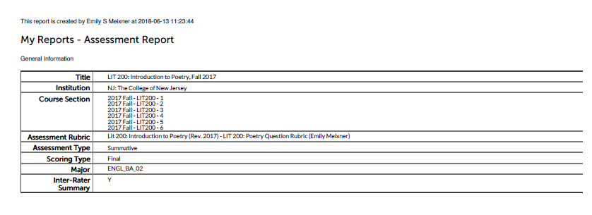

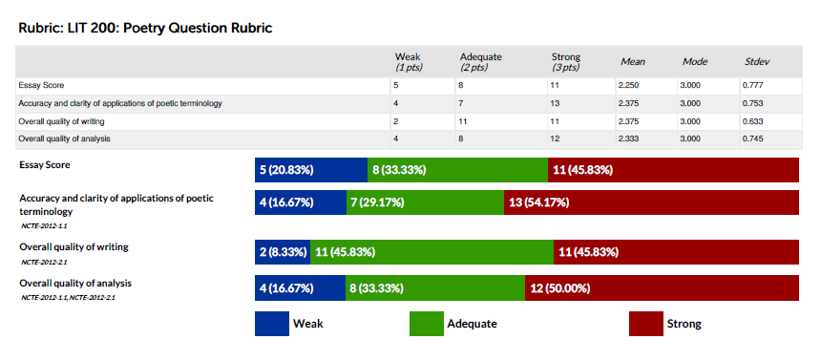

**Spring 2018, LIT 200: Poetry Question**

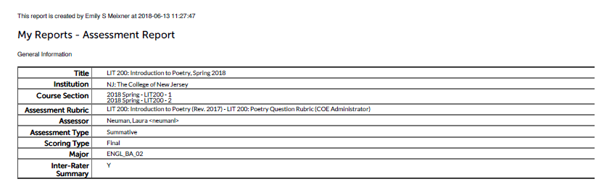

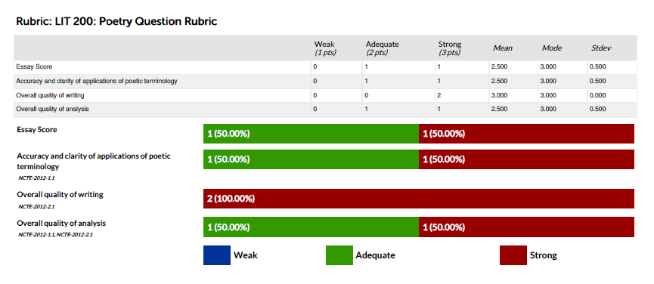

**Fall 2018, LIT 200: Poetry Question**

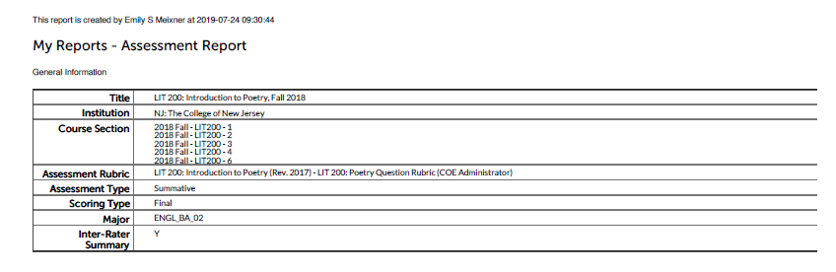

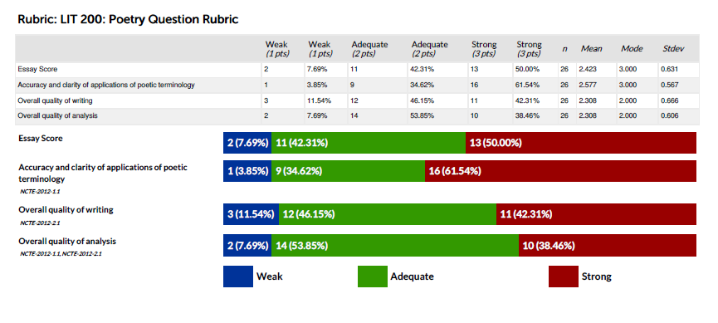

**Spring 2019, LIT 200: Poetry Question**

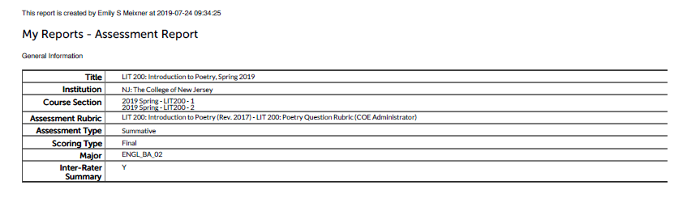

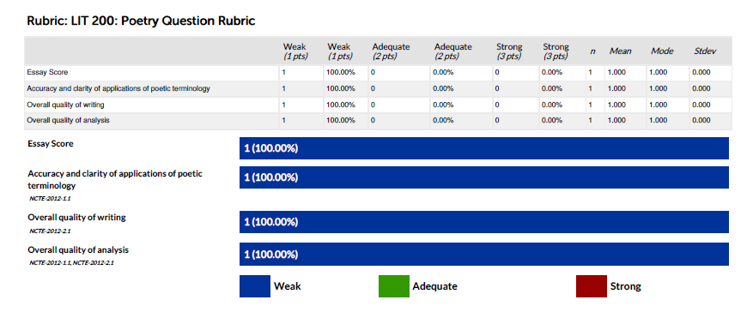

**Fall 2017, LIT 201: Approaches Question**

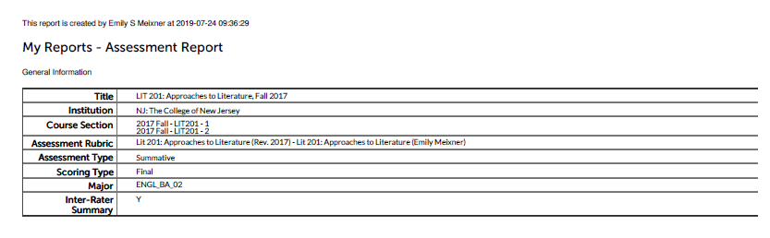

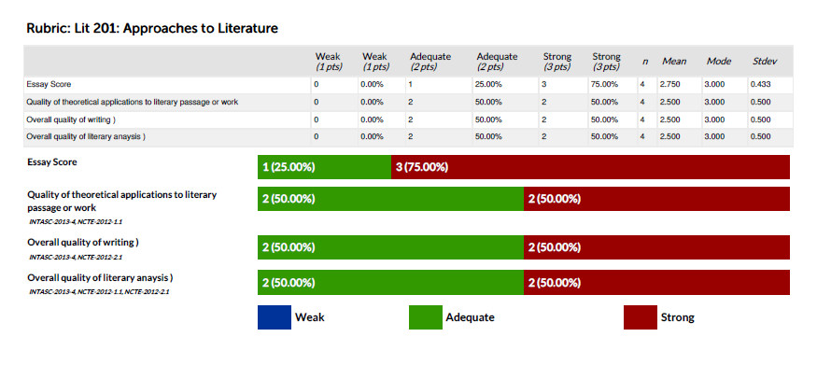

**Spring 2018, LIT 201: Approaches Question**

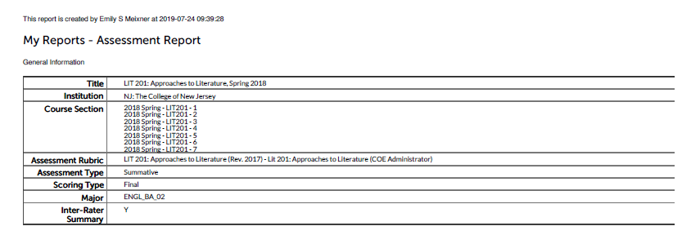

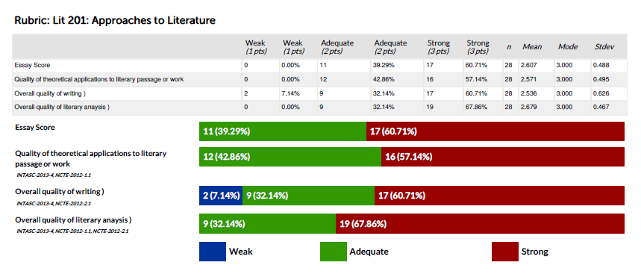

**Fall 2018, LIT 201: Approaches Question**

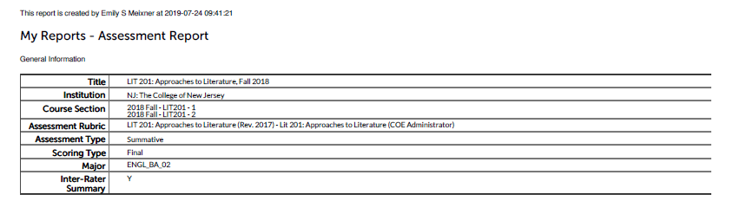

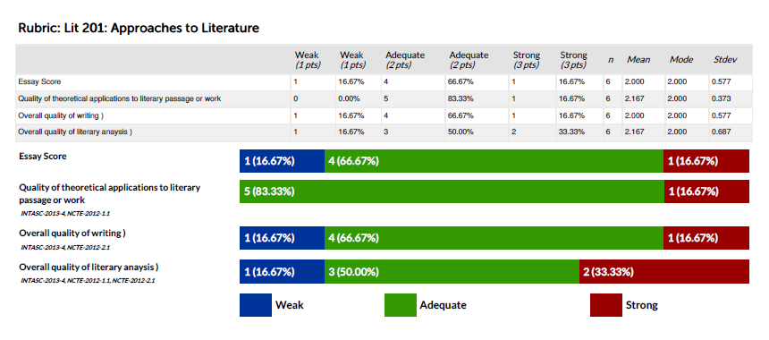

**Spring 2019, LIT 201: Approaches Question**

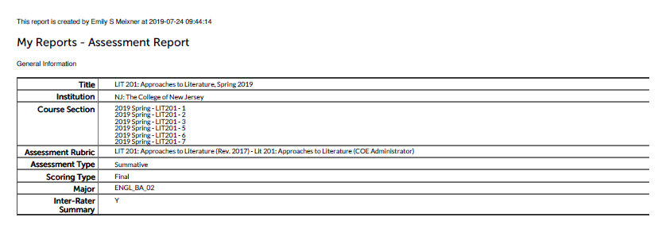

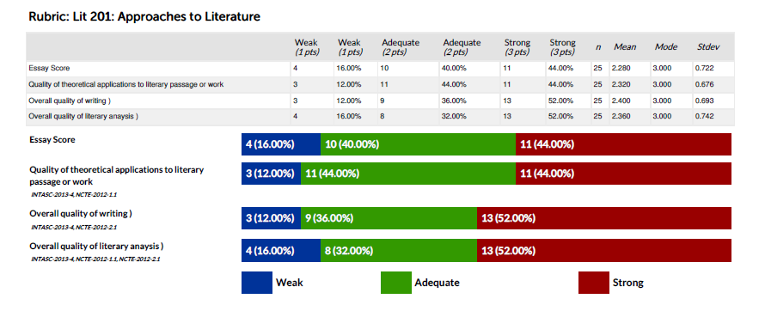

**Fall 2017, LIT 499: Research Paper (The title of this report is misnamed as Spring 2018, but the course sections indicate that the data was drawn from fall 2017 courses)**

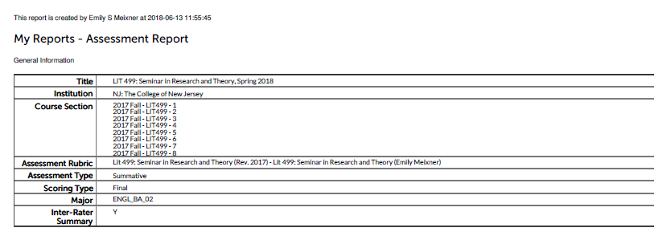

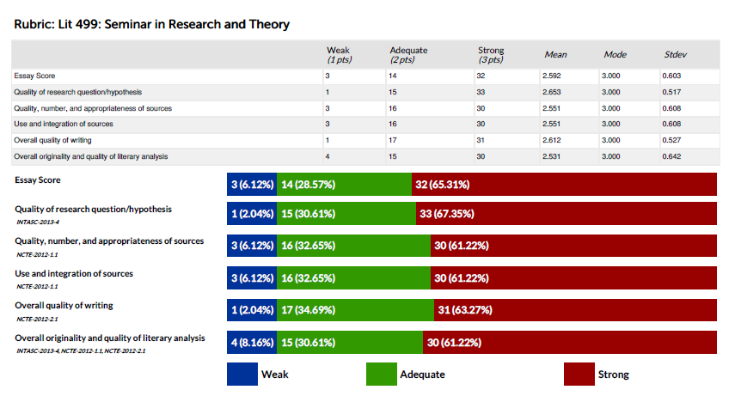

**Spring 2018, LIT 499: Research Paper**

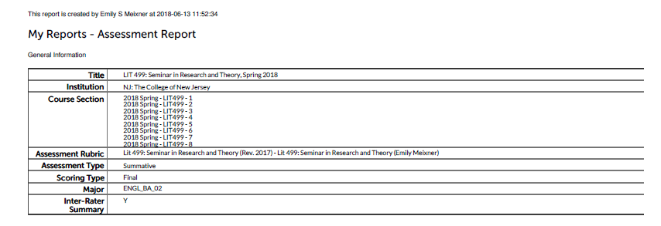

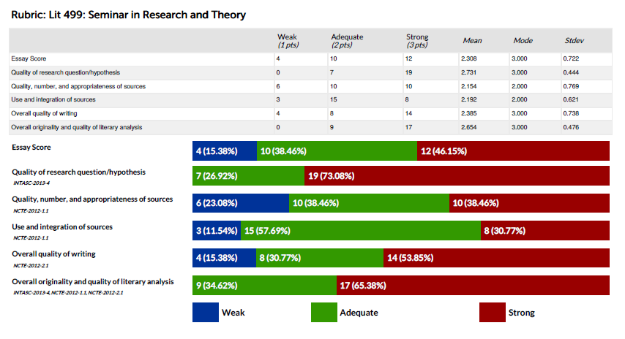

**Fall 2018, LIT 499: Research Paper**

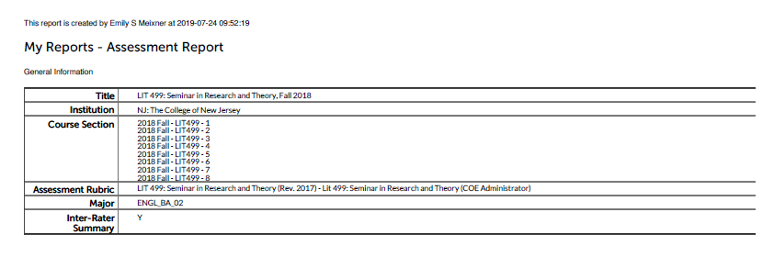

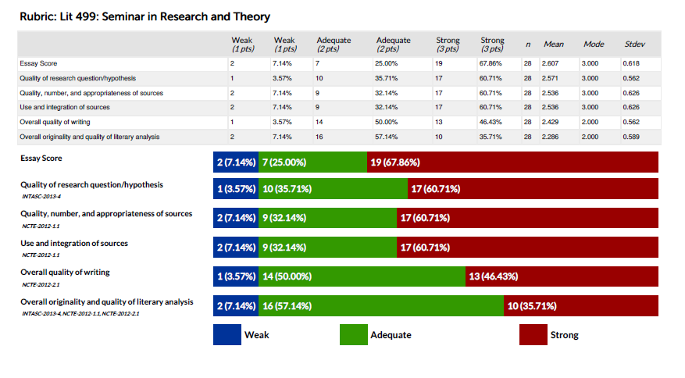

**Spring 2019, LIT 499: Research Paper**

