# 1 (REQUIRED)—CONTENT KNOWLEDGE: Data from licensure tests for content knowledge in English language arts.

PRAXIS II: #50038 English Language Arts: Content Knowledge

Affiliated NCTE Content Standards:
I. 1. Candidates are knowledgeable about texts—print and non-print texts, media texts, classic texts and contemporary texts, including young adult—that represent a range of world literatures, historical traditions, genres, and the experiences of different genders, ethnicities, and social classes; they are able to use literary theories to interpret and critique a range of texts.
II. 2. Candidates know the conventions of English language as they relate to various rhetorical situations (grammar, usage, and mechanics); they understand the concept of dialect and are familiar with relevant grammar systems (e.g., descriptive and prescriptive); they understand principles of language acquisition; they recognize the influence of English language history on English Language Arts content; and they understand the impact of language on society.

Assessment Narrative:

- The Praxis II exam is required for New Jersey licensure. The pass score for the State of New Jersey is 167. Secondary English education candidates take this exam prior to entry into their Clinical 2 (student teaching) semester. They must pass the exam prior to the completion of student teaching and, as a result, may not apply for certification without a passing score.

- As noted in the NCTE Program Review Documents, there is no direct correlation between the Praxis II Examination and the NCTE/CAEP standards for English Language Arts. Rather, the test has been designed to align with the Common Core State Standards (CCSS) for English Language Arts. Therefore, the test measures “examinees’ skills and knowledge of concepts relevant to three categories: reading, including the study of literature (i.e., stories, drama, and poetry) and informational texts (i.e., literary nonfiction, such as essays, biographies, and speeches); use of the English language, including conventions of standard English and vocabulary development; and writing, speaking, and listening” (Praxis Study Companion). However, this test does cover content knowledge in a wide range of literatures and informational text, grammar, composing processes, and media literacy as required by NCTE and articulated by NCTE Standards I.1 and II.2. Requiring this test is one way of ensuring that our candidates graduate from our program with necessary and robust content knowledge.

- According to the data on secondary English education candidate who took the Praxis Exam #50038, TCNJ candidates typically do well on the exam, regularly achieving scores above the national median. Candidate scores, however, do reveal a decrease between the years 2015-2018. In the year 2015-2016 with a sample of 27 test-takers, the average candidate praxis score was 183. In the year 2016-2017, the average score decreased slightly to 182, and in the year 2017-2018, candidates’ average scores decreased to 178, the national median.

What this data does not indicate is that in the year 2017-2018, the number of test takers includes several students (3) who took the text twice. Because every secondary English education candidate must pass the Praxis 2 to apply for their teaching license, all of our graduating candidates ultimately achieved a passing score on the exam.

- In terms of our candidates’ subscores, they are typically consistent year-to-year and align closely with the national performance ranges. This was the case in both years 2016-2017 and 2017-2018. When we disaggregate the subscore data, the majority of our teacher candidates achieve mid-range scores (31-35) in the “Reading” category. They perform most strongly in the “Writing, Speaking and Listening,” with the majority of candidates earning upper range scores (33+). The category in which their scores are lowest is “Language Use and Vocabulary.” These scores indicate that our candidates are demonstrating proficiency with respect to NCTE Standards I. 1 and II.2. However, we can look more closely at the assessment tasks included in the “Language Use and Vocabulary” components of the Praxis II exam to better prepare our candidates to respond to them.

Assessment Documentation:

Praxis Exam #5038 Scores, 2015-2018

Academic Year | # of Test Takers | NJ Passing Score | National Median | Mean | Performance Range | Pass Rate
2015-2016 | 27 | 167 | 178 | 183.1 | 164-199 | 92.29%
2016-2017 | 27 | 167 | 178 | 182.1 | 167-198 | 100%
2017-2018 | 29 | 167 | 178 | 178 | 153-194 | 82.75%

Praxis Exam #5038 Subscores, 2016-2018

Academic Year | - Reading (38%) | II. Language Use and Vocabulary (25%) | III. Writing, Speaking, and Listening (37%)
National Performance Ranges | Performance Range  (28-35) | Performance Range (19-24) | Performance Range (27-33)
2016- 2017 | (26-39)  Mean Score: 32.5 | (19-26)  Mean Score: 22 | (25-38)  32.2
2017-2018 | (27-39)  Mean Score: 33 | (18-26)  Mean Score: 21.6 | (24-36)  Mean Score: 32

Praxis Exam #5038 Subscores, 2016-2018 (Distributions)
Academic Year | - Reading (38%) | II. Language Use and Vocabulary (25%) | III. Writing, Speaking, and Listening (37%)
2016- 2017 | 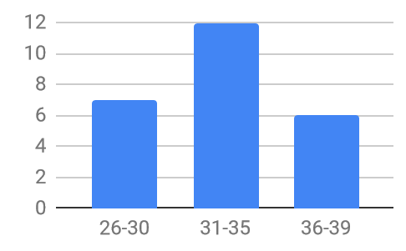 | 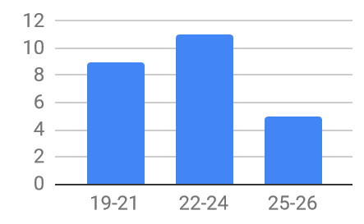 | 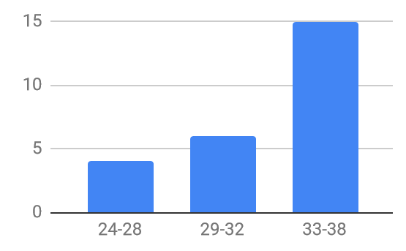
2017-2018 | 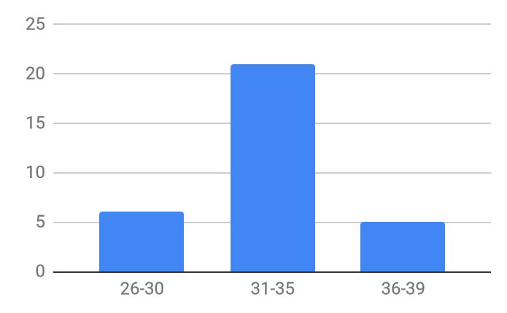 | 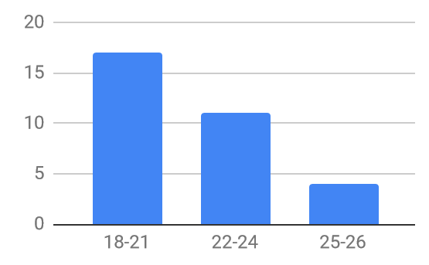 | 